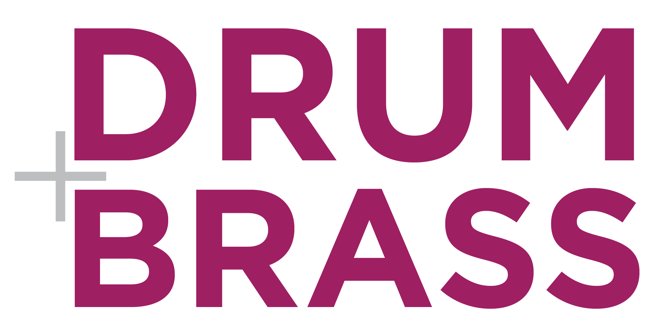

Name of Policy: | Health and Safety | Approved by:
Version number: | 01 | Ratified by: | Davina Vencatasamy  Julie Hoggarth  Hari Trivedi
Date Created: | June 2020 | In use: | June 2020
Date Reviewed: | Sept 2022 | KBJ JM DV
Date Reviewed: | Sept 2023 | KBJ DV
Date Reviewed: | March 2024 | KBJ JM SM AS DV
Next review date | March 2025 | Written by: | Kim Burley Jones

Target Audience | - All staff – for the purposes of this policy this means directors, employees, freelancers, sessional workers, volunteers.  - Project partners  - Project participants  All other users of Drum and Brass’s services
Exceptions to this policy | None
Related documents | Risk assessments; safeguarding policy; code of conduct; lone working policy; online working policy

Contents Page
1.0 Document Details
1.1 Introduction ……………………………………………………………………………. p 2
2.0 Main Policy Content ……………………………………………………………………………. p 2
3.0 Management Structure
3.1 Implementation of policy………………………………………………………..……. p 4
3.2 Duties and responsibilities………………………………………………………..… p 4

3.3 Evaluation and monitoring of policy……………………………………………. p 5
4.0 Resources
4.1 References…………………………………………………………………………….. p 5
4.2 Links……………………………………………………………………………………. p 5
  - Introduction

Drum and Brass aims to provide and maintain safe and healthy working conditions, equipment and systems of work for all employees, and to provide such information, training and supervision as they need for this purpose. We also accept responsibility for the health and safety of other people who may be affected by our activities.

When working on an outreach basis we will discuss health and safety matters with project partners and responsibilities will be clarified. The H&S policies of the venue or space in which we work will supersede this H&S policy.

The allocation of duties for safety matters and the particular arrangements that we will make to implement health and safety matters are set out in this Health & Safety Policy.

The policy will be kept up to date, particularly if the business changes in nature and size. To ensure this, the policy and the way in which it is operated will be reviewed every year.

2.0 Main Policy Content

2.1 Drum and Brass will pay particular regard to:

1. Providing information and instruction to enable all employees and sessional staff to contribute positively to their health and safety at work and to ensure the health and safety of groups and individuals within workshops.
- Ensure that the venue or space in use is kept in a safe and clean condition, via regular cleaning, maintenance and repair, and through staff looking for and removing hazards which may cause risk of accident to employees and users of that space or building.
3. Maintaining all equipment, and in particular electrical equipment in a safe and
clean condition, via regular cleaning, maintenance and repair.
Proper use of such equipment will be ensured via appropriate staff training.
4. Ensuring that at all times fire exits within the venue or space in use are clearly marked, unlocked and free from obstruction, and ensuring the premises managers have regularly maintained and tested all fire-fighting equipment.
5. When working with client groups, to ensure the health and safety of project participants, through adequate supervision and correct and safe use of equipment and materials.
6. Working to other organizations’ health and safety guidelines when running projects at their premises and ensuring that health and safety and risk assessments for the activities we provide will be adequately supervised.

Fire procedures at the venue used by Drum and Brass employees

Venues will be required to give Drum and Brass staff an annual ‘walk-round’. This will involve a refresher on: location of fire extinguishers / location of first aid supplies / location of emergency exits / procedures in case of need to vacate the premises in an emergency situation.
Fire Drills should take place on an annual basis.

Accidents
All accidents, however minor, should be reported to the Director responsible for H&S and recorded in the
Accident Book. This book will be kept in a locked cabinet.

First Aid
Staff must make themselves aware of the location of first aid boxes in the space or venue they are using.

Use of Substances Hazardous to Health
If at any time, Drum and Brass staff use substances which may be hazardous to health, all these substances will be COSHH (control of substances hazardous to health) -assessed to see if the use of these substances is really necessary (particularly when working with groups on projects away from the premises) and if so we will follow precautions given by manufacturers.

Materials/substances
Suitability for use will be checked by Director responsible for H&S. Director responsible for H&S will also ensure that any relevant information for safe use of materials/substances is passed on to all staff.

Risk Assessment
Employees will be encouraged to look out for and report hazards within the session or workshop space or venue which may cause risk of accident, as a matter of daily routine.
All new projects will be risk assessed by the Directors involved in the activity and the project co-ordinators and reported to Director responsible for H&S who will take any necessary action.

Training Records
All relevant qualifications and training records will be kept on file by Director responsible for H&S. These will be monitored and updated when necessary.

Work-related stress
Risk assessments include the consideration and identification of causes of stress.
The following are taken into account for each person’s job:
- Demands – workload and the work environment.
- Control – how much say the person has in the way they do their work.
- Support – the encouragement and resources provided by the organisation, line management and colleagues.
- Relationships – promoting positive working to avoid conflict and dealing with unacceptable behaviour.
- Role – whether people understand their role within the organisation and whether the organisation ensures that they do not have conflicting roles.
- Change – how organisational change is managed and communicated in the organisation.

Directors have the following responsibilities with regard to minimising stress to staff and providing support if it should occur:
- Ensuring staff do not work excessively long hours and that allocated rest breaks and holidays are taken as appropriate.
- Monitoring workloads to ensure that staff are not overloaded.
- Giving the opportunity to discuss work-related stress.

Where work-related stress is identified, rearranging work allocation, introducing flexible working patterns and providing work-related training/mentoring are considered and agreed as appropriate.
Drum and Brass does not tolerate bullying or harassment. This is clearly stated in both the company’s Equality and Diversity Policy and Code of Conduct.

3.0 Management Structure

Health and safety representative
The person with overarching responsibility for health and safety matters at Drum and Brass is Director responsible for H&S. Any questions about this policy or any matters arising concerning health and safety should be referred to Director responsible for H&S. The other directors hold responsibility for H&S within the projects they oversee. Full details of the responsibilities of all workers for health and safety matters are located in the Duties and Responsibilities section.

3.1 Implementation of policy

Drum and Brass aims to provide a healthy and safe working environment for employees, groups and individuals using any premises we use and when we run outreach workshops with partner organisations. In order to ensure that this is achieved, Drum and Brass requires the full cooperation of all employees to have a general duty of care to themselves, sessional staff, clients, members of the public or other visitors to Drum and Brass’s workshops in the community. The Drum and Brass Health and Safety Statement and Policy will be covered in induction and should be read in conjunction with other policies and guidance as identified above.

3.2 Duties and responsibilities

All Directors:
Ensure that the company fulfills its legal obligations and that the policy is positively implemented.
- Ensure day-to-day implementation of the policy within their areas of responsibility.
- Make all staff under their supervision aware of the policy and their responsibilities within it.

Director responsible for health and safety:
- Ensure all employees are suitably trained to carry out their duties safely.
- Ensure that any hazards and health risks are identified and dealt with as soon as possible.
- Ensure all new employees are given training and receive all relevant information.
- Review training needs regularly.
- Identify any specialised training due to new types of projects.
- Regularly monitor working conditions within the building affecting employees and visitors.
- Advise management and staff on health and safety issues.
- Ensure all accidents are investigated and any operational changes necessary are introduced.

Workshop and project co-ordinators:
- To be fully aware of the company’s health and safety policy and ensure its implementation in all projects.
- Ensure all project staff and participants are aware of relevant health and safety issues.
- Regularly inspect all areas of premises used for health and safety issues.
- Report to directors any health and safety issues that arise including breaches.
- Maintain records of all accidents.
- Regularly carry out visual checks on electrical equipment and carry out PAT testing at designated intervals.
- Ensure fire extinguishers are regularly checked and accessible.
- Ensure all new workers and users are aware of emergency and evacuation procedures.

3.3 Evaluation and monitoring of policy
This policy will be reviewed by all Drum and Brass directors yearly, and updated as circumstances change. This review will take place during a formal directors meeting and the process and conclusions will be recorded in the minutes.

uuu

4.0 Resources
4.1 References
4.2 Links: Risk assessments; safeguarding policy; code of conduct; lone working policy; online working policy

